Please share these infographics on your social media platforms. Be sure to tag (@) us in your post by using the following social media handles. | • Instagram @MNADV  • Twitter @MNADV  • Facebook @marylandnetwork

Infographic images.  Right click on the image to save to your electronic device or computer. | Content to copy and paste into your post!  Note: individual to each image; please don’t mix and match. | Hashtags to copy and paste into your post!  Note: individual to each image; please don’t mix and match.
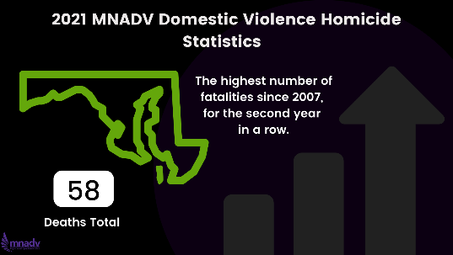 | While in 2020, we saw a drastic increase in fatalities compared to previous years (the highest number since 2007 at 56 lives lost), in 2021, a staggering 58 Marylanders lost their lives due to intimate partner violence. | #StoptheincreaseinDVMD  #StopDVhomicideinMD  #MNADV34Memorial  #EndDVhomicideMD  #helpiscloseby
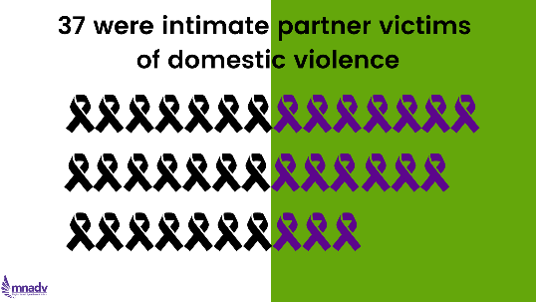 | Of 2021’s 58 deaths, 37 were intimate partner victims in abusive relationships. | #StoptheincreaseinDVMD  #StopDVhomicideinMD  #MNADV34Memorial  #EndDVhomicideMD  #helpiscloseby
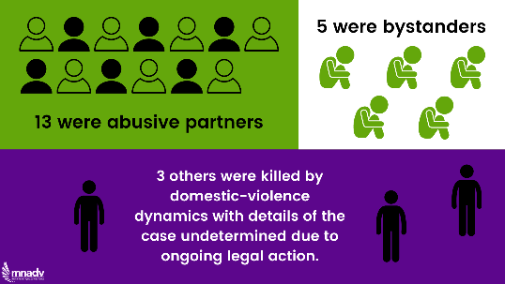 | Of 2021’s 58 deaths, 13 were abusive partners, 5 (including two children) were bystanders, and 3 others were killed within a situation of domestic violence wherein the dynamics are still being determined by the legal system. | #StoptheincreaseinDVMD  #StopDVhomicideinMD  #MNADV34Memorial  #EndDVhomicideMD  #helpiscloseby
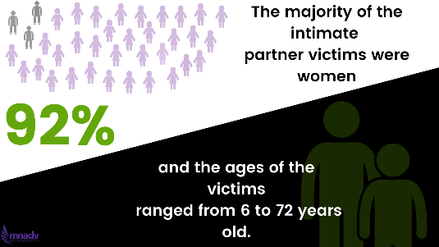 | The majority of intimate partner victims in 2021 were women at 92%. Ages of all victims ranged from 6 years to 72 years old. | #StoptheincreaseinDVMD  #StopDVhomicideinMD  #MNADV34Memorial  #EndDVhomicideMD  #helpiscloseby
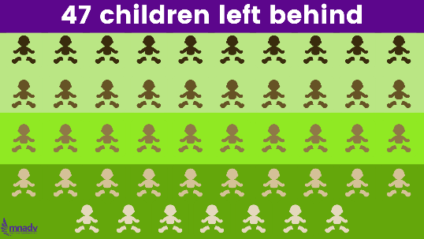 | 47 children under 18 were left without one or both of their parents due to intimate partner violence this year. | #StoptheincreaseinDVMD  #StopDVhomicideinMD  #MNADV34Memorial  #EndDVhomicideMD  #helpiscloseby  #childrenofDVMD
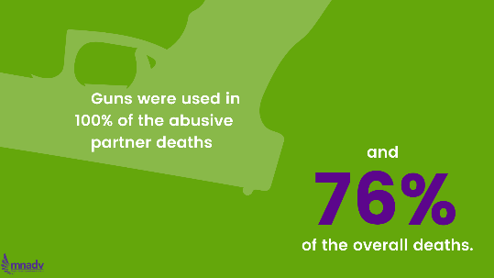 | Gun violence is on the rise and contributed to many of this year’s deaths. 100% of all abusive partners and 76% of all domestic violence victims in 2021 were killed with a gun. | #StoptheincreaseinDVMD  #StopDVhomicideinMD  #MNADV34Memorial  #EndDVhomicideMD  #helpiscloseby  #GunViolenceinMD
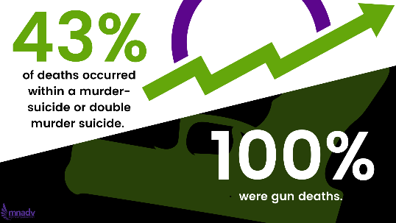 | 43% of this year’s deaths occurred within the context of a murder suicide, double murder suicide, or attempted murder suicide. 100% of murder or double murder suicides this year were gun deaths. | #StoptheincreaseinDVMD  #StopDVhomicideinMD  #MNADV34Memorial  #EndDVhomicideMD  #helpiscloseby  #GunViolenceinMD
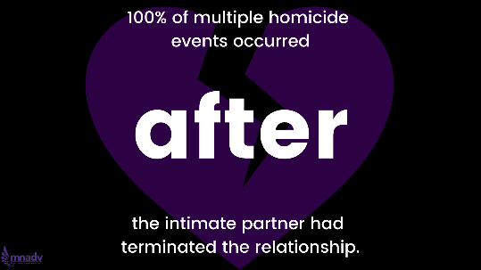 | 100% of multiple homicide events (meaning double homicides or double murder suicides) occurred after the intimate partner had terminated the relationship. | #StoptheincreaseinDVMD  #StopDVhomicideinMD  #MNADV34Memorial  #EndDVhomicideMD  #helpiscloseby  #WhyIStayed  #SafetyPlanning
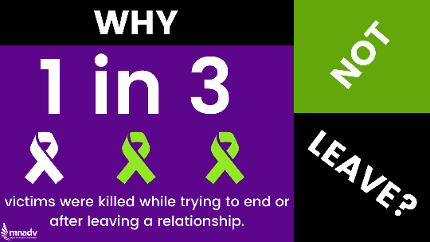 | Why not just leave? One third of intimate partner victims were killed while trying to end a relationship or after they already had. | #StoptheincreaseinDVMD  #StopDVhomicideinMD  #MNADV34Memorial  #EndDVhomicideMD  #helpiscloseby  #WhyIStayed  #SafetyPlanning
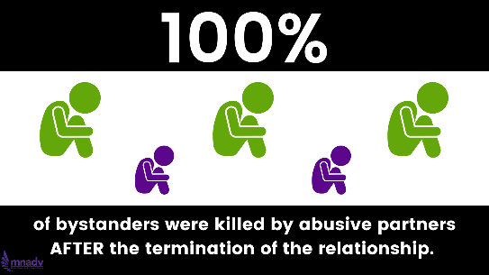 | Why not just leave? 100% of bystanders (including two minor children) were killed by abusive partners AFTER the termination of the relationship. | #StoptheincreaseinDVMD  #StopDVhomicideinMD  #MNADV34Memorial  #EndDVhomicideMD  #helpiscloseby  #WhyIStayed  #SafetyPlanning
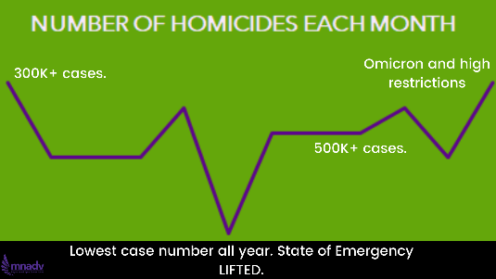 | The ongoing covid-19 pandemic may be worsening the risk of lethality in intimate partner violence scenarios. Spikes in homicides this year correlate to increased covid restrictions, what researchers in the field refer to as covid stress. | #StoptheincreaseinDVMD  #StopDVhomicideinMD  #MNADV34Memorial  #EndDVhomicideMD  #helpiscloseby  #Covid19
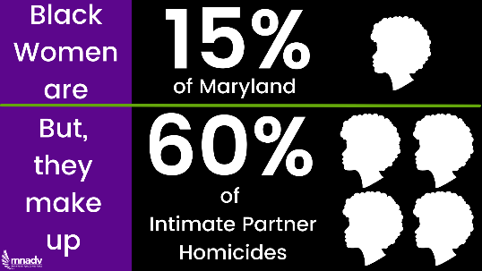 | Black women accounted for 60% of Intimate partner victims in 2021. For context, black women make up only 15% of Maryland’s population, meaning Black Women are being killed by their intimate partners at a rate nearly four times their rate in the population. | #StoptheincreaseinDVMD  #StopDVhomicideinMD  #MNADV34Memorial  #EndDVhomicideMD  #helpiscloseby  #BlackHistoryMonth  #ProtectBlackWomen
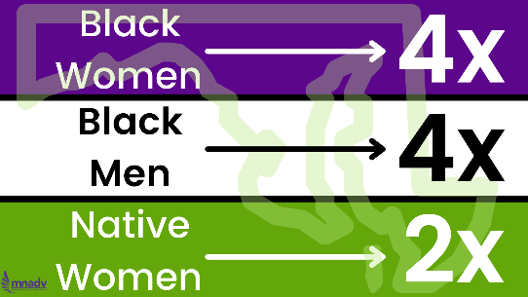 | Of 6 men who died due to IPV dynamics this year (both intimate partners and bystanders), 2/3rds were Black Men. Black men make up only about 15% of Maryland’s population, so they are overrepresented here BY FOUR TIMES. | #StoptheincreaseinDVMD  #StopDVhomicideinMD  #MNADV34Memorial  #EndDVhomicideMD  #helpiscloseby  #BlackHistoryMonth
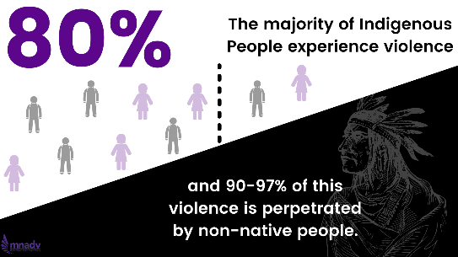 | Three of the deaths this year (including one 6 year old child) were attributed to Indigenous Women of Piscataway Conoy ancestry, all of whom were killed by non-native men. Native Women are overrepresented in homicides due to IPV by double their proportion in the population. Native women and men have the highest rates of IPV compared to any other racial group. Roughly 80% of Native People will experience violence in their lifetime, and a startling 90-97% of this violence is perpetrated by Non-Native People. | #StoptheincreaseinDVMD  #StopDVhomicideinMD  #MNADV34Memorial  #EndDVhomicideMD  #helpiscloseby  #IndigenousWomenMD
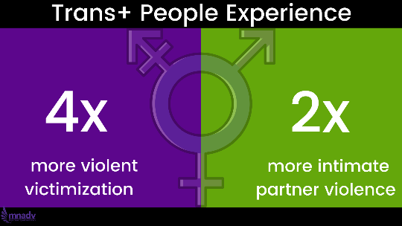 | One Black Trans Woman was killed this year by an intimate partner, that we know of. Transgender people are over four times more likely than cisgender people to experience violent victimization, and are almost twice as likely to experience IPV. | #StoptheincreaseinDVMD  #StopDVhomicideinMD  #MNADV34Memorial  #EndDVhomicideMD  #helpiscloseby  #BlackHistoryMonth  #ProtectTransLives
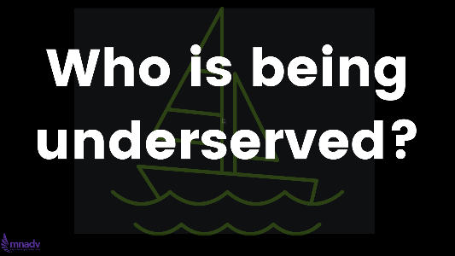 | Intimate partner homicide is an intersectional issue requiring culturally humble solutions. While we are all in the same storm, we are not all in the same boats. Who are we underserving? | #StoptheincreaseinDVMD  #StopDVhomicideinMD  #MNADV34Memorial  #EndDVhomicideMD  #helpiscloseby
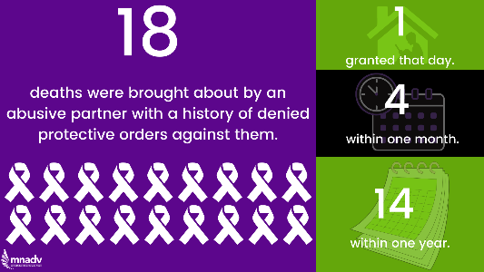 | 18 deaths were brought about by an abusive partner with a history of denied protective orders against them. 14 deaths occurred within one year of the denial of a PO, 4 occurred within months of the denial of a PO, and 1 child was slain as his mother, after numerous tries, was finally granted a DVPO. | #StoptheincreaseinDVMD  #StopDVhomicideinMD  #MNADV34Memorial  #EndDVhomicideMD  #helpiscloseby
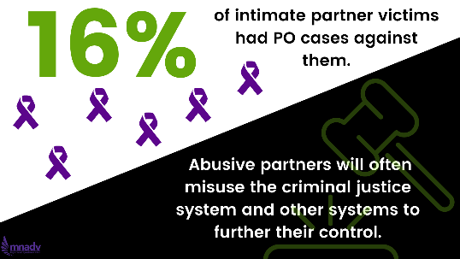 | 6 intimate partner victims (16%) had protective order cases against them, demonstrating how perpetrators can misuse a system meant to protect victims to further discredit and terrorize them instead. | #StoptheincreaseinDVMD  #StopDVhomicideinMD  #MNADV34Memorial  #EndDVhomicideMD  #helpiscloseby  #AbusingtheSystem  #ProtectSurvivors
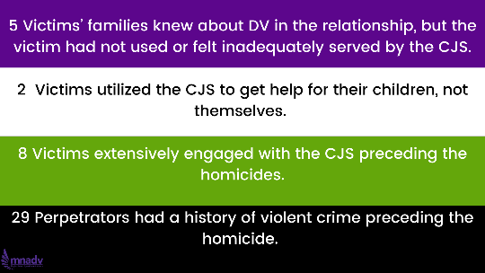 | In five cases, the victims’ families told the press that although they knew about and had witnessed DV in the relationship, the victim had not used or felt inadequately served by the criminal justice system. In 2 other cases, victims had utilized the CJS to get help for their children, but not themselves. Finally, eight victims extensively engaged with the CJS preceding the homicides. Related to this, 29 perpetrators had a history of violent crime preceding the homicide. | #StoptheincreaseinDVMD  #StopDVhomicideinMD  #MNADV34Memorial  #EndDVhomicideMD  #helpiscloseby  #JusticeforSurvivors
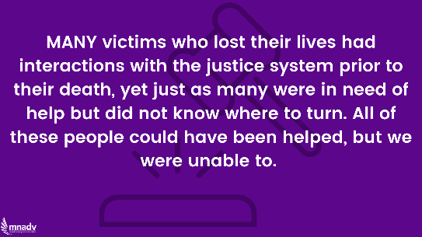 | Many victims who lost their lives had interactions with the justice system prior to their death, yet just as many were in need of help but did not know where to turn. All of these people could have been helped, but we were unable to. We hope to build a Maryland where that is no longer the case. We imagine a Maryland free of violence. | #StoptheincreaseinDVMD  #StopDVhomicideinMD  #MNADV34Memorial  #EndDVhomicideMD  #helpiscloseby  #JusticeforSurvivors  #FreeMDfromDV

